Ideation Phase
Define the Problem Statements

Date | 28 June 2026
Team ID
Project Name | shopEZ-MERN E-commerce Application
Maximum Marks | 2 Marks

Customer Problem Statement Template:
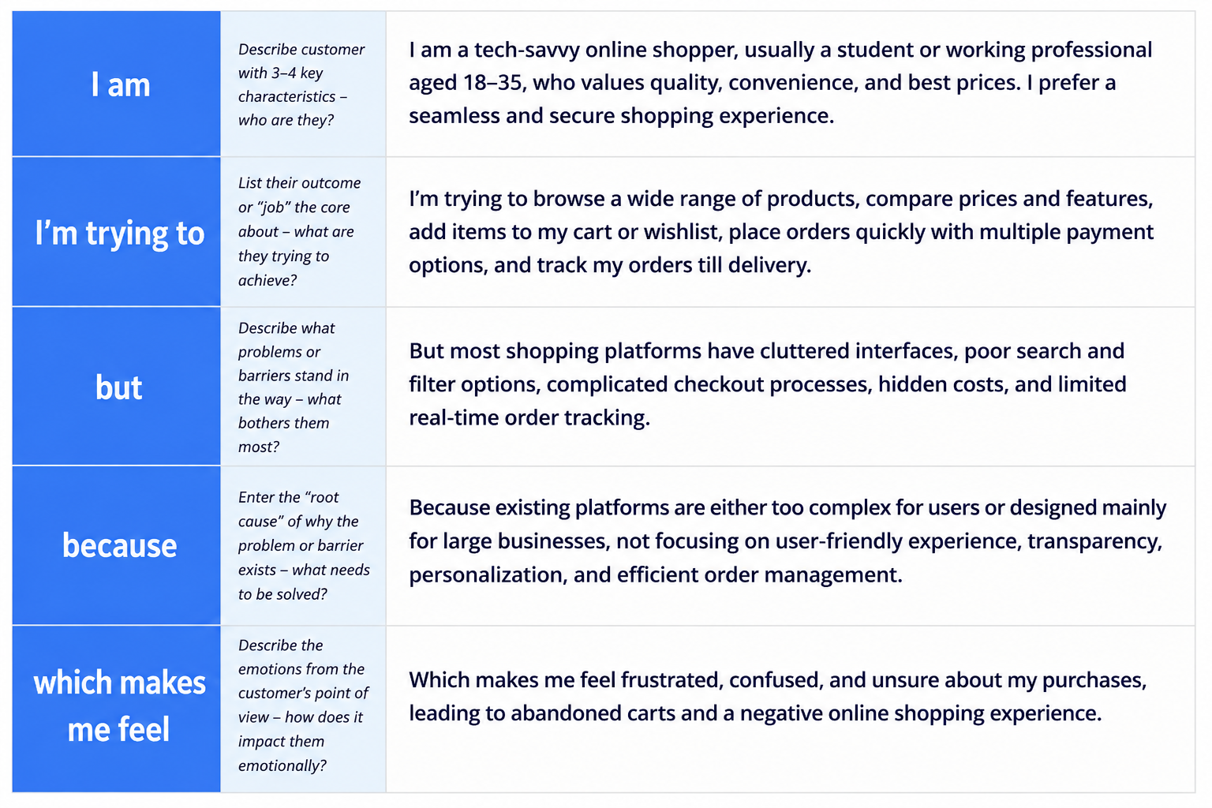Example:
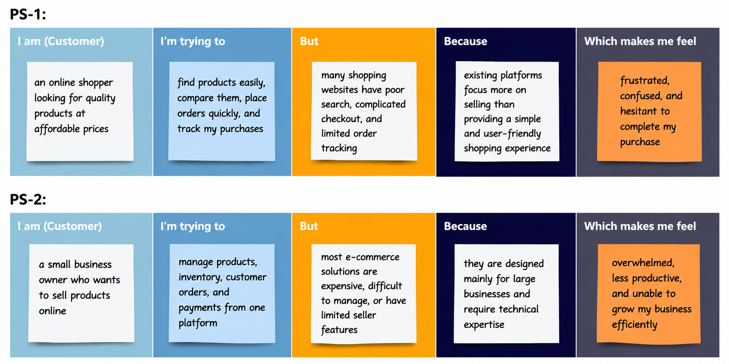

Problem Statement (PS) | I am (Customer) | I’m trying to | But | Because | Which makes me feel
PS-1 | I am an online shopper looking for quality products at affordable prices. | Find products easily, compare them, place orders quickly, and track my purchases. | Many shopping websites have poor search, complicated checkout, and limited order tracking. | Existing platforms focus more on selling than providing a simple and user-friendly shopping experience. | Frustrated, confused, and hesitant to complete my purchase.
PS-2 | I am a small business owner who wants to sell products online. | Manage products, inventory, customer orders, and payments from one platform. | Most e-commerce solutions are expensive, difficult to manage, or have limited seller features. | They are designed mainly for large businesses and require technical expertise. | Overwhelmed, less productive, and unable to grow my business efficiently.

